**Architecture Design**

**Analyze International Debt Statistics**

**Revision Number - 1.0**

**Last Date of Revision - 03/11/2022**

**Rushabh Halmare**

ARCHITECTURE DESIGN

**Document Control**

|  |  |  |  |
| --- | --- | --- | --- |
| **Date** | **Version** | **Description** | **Author** |
|  |  |  |  |
| 05/10/2022 | 1.0 | Introduction, | Rushabh Halmare |
|  |  | Architecture, |  |
|  |  | Deployment |  |
|  |  |  |  |
| 03/10/2022 | 1.0 | Final Revision | Rushabh Halmare |
|  |  |  |  |

ARCHITECTURE DESIGN

**Contents**

Document Version Control…………………………………………………………………………2

1. Introduction……………………………………………………………………………...……...4

1.1 What is Architecture Design Document….……………………………………..…...……...4

1.2 Scope………………………………………………………………………………….……4

1. Architecture……………………………………………………....……………………..……...4

2.1 Tableau Architecture…………………………………………………………….………....4

2.2 Components of Tableau Architecture ………………………………………………………5

1. Deployment…………………………………………………………………………………….7

3.1 Tableau Deployment…………………………………………………………………….…7

3.2 Publish datasets and reports from Tableau Desktop……………..…………………………7



ARCHITECTURE DESIGN

**1. Introduction**

* 1. **What is Architecture Design Document?**

The architecture design document is a technical document describing the components and specifications required to support the solution and ensure that the specific business and technical requirements of the design are satisfied. Any software needs the architectural design to represent the design of the software. IEEE defines architectural design as “the process of defining a collection of hardware and software components and their interfaces to establish the framework for the development of a computer system.” The software that is built for computer-based systems can exhibit one of these many architectures. Each style will describe a system category that consists of:

* A set of components (eg: a database, computational modules) that will perform a function required by the system.
* The set of connectors will help in coordination, communication, and cooperation between the components.
* Conditions that how components can be integrated to form the system.
* Semantic models help the designer to understand the overall properties of the system.

**1.2 What is Scope?**

Architecture Design Document (ADD) is an architectural design process that follows a step-by-step refinement process. The process can be used for designing data structures, required software architecture, source code and ultimately, performance algorithms. Overall, the design principles may be defined during requirement analysis and then refined during architectural design work.

The scope of this document is limited to description of the architectural elements, data types, data flows, user interfaces, etc.

**2. Architecture**

**2.1 Tableau Architecture**

Tableau Server is designed to connect many data tiers. It can connect clients from Mobile, Web, and Desktop. Tableau Desktop is a powerful data visualization tool. It is very secure and highly available.

It can run on both the physical machines and virtual machines. It is a multi-process, multi-user, and multi-threaded system.

Providing such powerful features requires unique architecture.

The different layers used in Tableau server are given in the following architecture diagram:

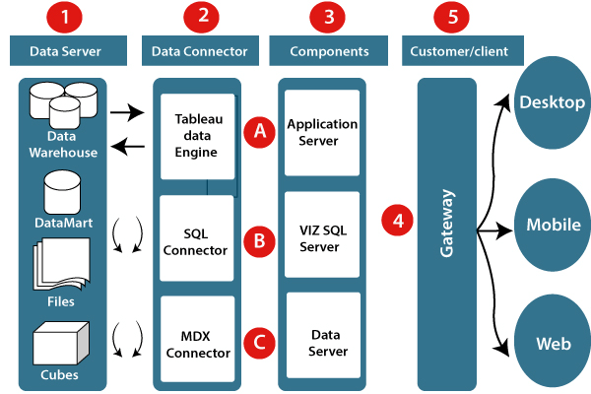



**2.2 Components of Tableau Architecture**

1. **Data server:** The primary component of Tableau Architecture is the Data sources which can connect to it.

Tableau can connect with multiple data sources. It can blend the data from various data sources. It can connect to an **excel file, database**, and a **web application** at the same time. It can also make the relationship between different types of data sources.

1. **Data connector:** The Data Connectors provide an interface to connect external data sources with the Tableau Data Server.

Tableau has in-built SQL/ODBC connector. This ODBC Connector can be connected with any databases without using their native connector. Tableau desktop has an option to select both extract and live data. On the uses basis, one can be easily switched between live and extracted data.

* **Real-time data or live connection:** Tableau can be connected with real data by linking to the external database directly. It uses the infrastructure existing database by sending dynamic **multidimensional expressions (MDX)** and SQL statements. This feature can be used as a linking between the live data and Tableau rather than importing the data. It makes optimized and a fast database system. Mostly in other enterprises, the size of the database is large, and it is updated periodically. In these cases, Tableau works as a front-end visualization tool by connecting with the live data.
* **Extracted or in-memory data:** Tableau is an option to extract the data from external data sources. We make a local copy in the form of Tableau extract file. It can remove millions of records in the Tableau data engine with a single click. Tableau's data engine uses storage such as **ROM, RAM**, and **cache** memory to process and store data. Using filters, Tableau can extract a few records from a large dataset. This improves performance, especially when we are working on massive datasets. Extracted data allows the users to visualize the data offline, without connecting to the data source.

1. **Components of Tableau server:** Different types of component of the Tableau server are:

* Application server
* VizQL server
* Data server

1. **Application server:** The application server is used to provide the authorizations and authentications. It handles the permission and administration for mobile and web interfaces. It gives a guarantee of security by recording each session id on Tableau Server. The administrator is configuring the default timeout of the session in the server.
2. **VizQL server:** VizQL server is used to convert the queries from the data source into visualizations. Once the client request is forwarded to the VizQL process, it sends the query directly to the data source retrieves information in the form of images. This visualization or image is presented for the users. Tableau server creates a cache of visualization to reduce the load time. The cache can be shared between many users who have permission to view the visualization.
3. **Data server:** Data server is used to store and manage the data from external data sources. It is a central data management system. It provides **data security, metadata management, data connection, driver requirements**, and data storage. It stores the related details of data set like **calculated fields, metadata, groups, sets**, and **parameters**. The data source can extract the data as well as make live connections with external data sources.
4. **Gateway:** The gateway directed the requests from users to Tableau components. When the client sends a request, it is forwarded to the external load balancer for processing. The gateway works as a distributor of processes to different components. In case of absence of external load balancer, the gateway also works as a load balancer. For single server configuration, one gateway or primary server manages all the processes. For multiple server configurations, one physical system works as a primary server, and others are used as worker servers. Only one machine is used as a primary server in Tableau Server environment.
5. **Clients:** The visualizations and dashboards in Tableau server can be edited and viewed using different clients. Clients are **a web browser, mobile applications**, and **Tableau Desktop**.

* **Web Browser:** Web browsers like **Google Chrome, Safari**, and **Firefox** support the Tableau server. The visualization and contents in the dashboard can be edited by using these web browser.
* **Mobile Application:** The dashboard from the server can be interactively visualized using mobile application and browser. It is used to edit and view the contents in the workbook.
* **Tableau Desktop:** Tableau desktop is a business analytics tool. It is used to **view, create**, and **publish** the dashboard in Tableau server. Users can access the various data source and build visualization in Tableau desktop.

ARCHITECTURE DESIGN

**3. Deployment**

**3.1 Tableau Deployment**

Prioritizing data and analytics couldn’t come at a better time. Your company, no matter what size, is already collecting data and most likely analyzing just a portion of it to solve business problems, gain competitive advantages, and drive enterprise transformation. With the explosive growth of enterprise data, database technologies, and the high demand for analytical skills, today’s most effective IT organizations have shifted their focus to enabling self-service by deploying and operating Tableau at scale, as well as organizing, orchestrating, and unifying disparate sources of data for business users and experts alike to author and consume content.

**3.2 Publish datasets from Tableau.**

The following steps give an overview of the publishing workflow you will use regardless of the type of data or the server you publish to. Below these steps you can find supplemental information for authentication types

1. Select **Server** > **Publish Data Source**.

If your workbook is connected to multiple data sources, select the one you want from the Publish Data Sources submenu.

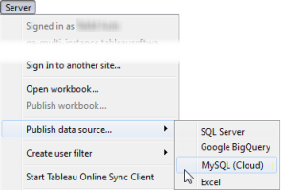

1. In the **Publish Data Source** dialog box, do the following:

* For **Project**, select the project you want to publish to and enter the data source name.
* For **Description** and **Tags**, add a description and tags that will help you and other users find it.

Separate tags using either a comma or a space. To add a tag that contains a space, put it in quotation marks (e.g., “Sales Quotes”).

* For **Refresh Schedule**, if publishing an extract, you have the option to select a refresh schedule to ensure that your extract data stays fresh. If you choose not to select a schedule here, you can select a schedule from Tableau Server after publishing.
* For **Authentication**, if you need to provide credentials to access your data, you can specify how authentication should be handled when the data is published to the server.

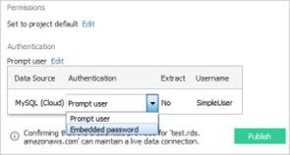

The options available for accessing the data source depend on the type of data you publish and whether you are publishing to Tableau Server or Tableau Online.

Information appears at the bottom of the dialog box to let you know whether you need to take further action, such as adding Tableau Online to your data provider's authorized list.

1. If By default, during the publishing process, Tableau updates the workbook connection to use the new published data source. It also closes the local data source.
2. To continue using the local data source instead, clear the **Update workbook to use the published data source** check box.
3. Click Publish.

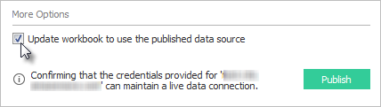

After publishing is complete, your web browser opens Ask Data for the data source, where you can ask questions to automatically create vizzes.

